**Database with relationships**

**Inside Migration File:**

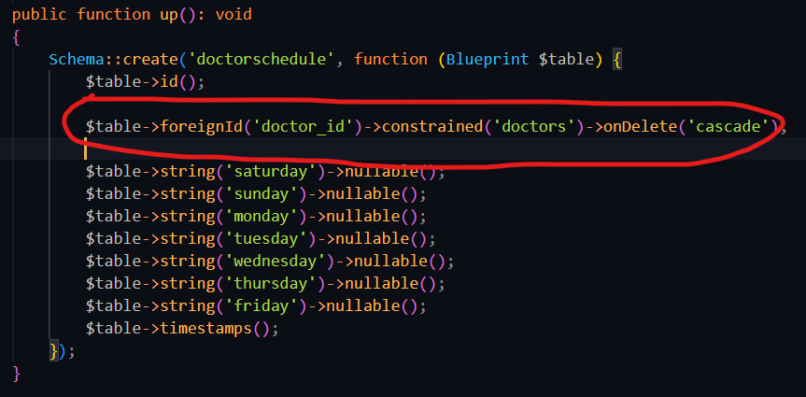

**Inside Model:**

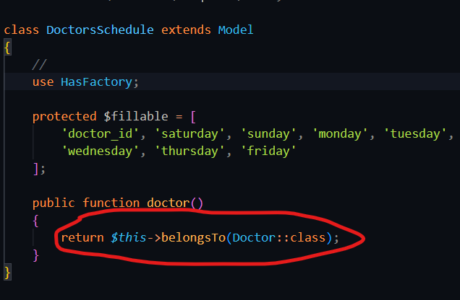

**Inside Factory:**



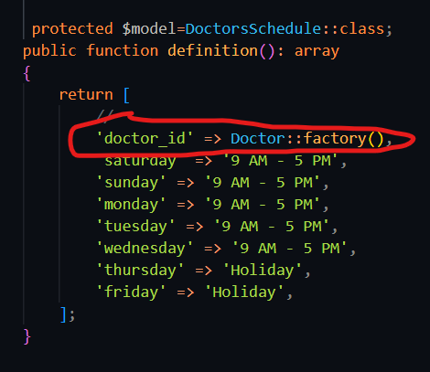

**Inside the model where the database model belongs to:  
create a function to define the relationship  
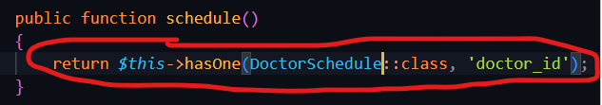**

**Inside the controller for this:**

